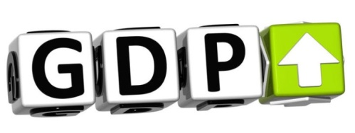
Comparing GDP
How helpful is this number in the analysis of a country?
The Top Ten
Find the top ten economies (country) by size (nominal GDP). What are they? Then, find the GDP per capita for each (use PPP), what do you notice about what changes? What are the top ten now?
Volunteering
The global value of volunteerism has been placed at $1.348 trillion (~2.4% of the entire global economy), but volunteerism doesn't count towards GDP. Should it? Examine the link here and comment on how GDP figures might be significantly altered globally if volunteerism was counted as part of annual production.
Limitations
GDP has many limitations as a measurement (some were mentioned in the lecture, others not). Which limitation appears to be the most difficult to overcome?
GNP vs. GDP
Naturally, the primary reason GDP was established in the 1980s was that the interconnectedness of the economies around the world had grown substantially from the 1930s. Global trade has boomed, and 1975 was the last time that the US had a trade surplus... examine this chart here, however as seen below, one of the most important things to consider is deficit in comparison to GDP. Based on what you are reading, how serious is the trade deficit situation?
Solutions for Trade Deficits?
President Trump has stated he'd end trade deficits. What evidence is out there that he has or hasn't?
