VSE – Stock Snap Shot #3
Your Stocks (Or five of your currently owned stocks if your portfolio has more)
Company Name | Stock Symbol | # of Shares Owned | $ Value of Stock | Gain or Loss from Stock Since Purchase

Which of the stocks that you currently own are you planning on trying to sell prior to the final date of trading (to lock in gains)?

Which of the stocks that you currently own are you planning to hold through the final date of trading (that you assume will keep rising)?

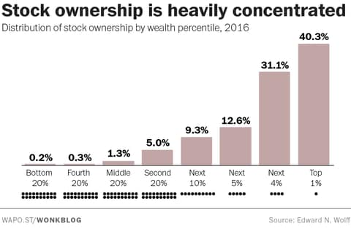
Looking at this graph, why would economists likely warn against using the stock market measurements (DOW, S&P 500, etc) as the primary measurement on how the economy as a whole is doing?

