VSE – Stock Snap Shot #2
Your Stocks (Or five of your currently owned stocks if your portfolio has more)
Company Name | Stock Symbol | # of Shares Owned | $ Value of Stock | Gain or Loss from Stock Since Purchase

With still over a month left in the simulation…
What has been your most lucrative stock to date? What are your feelings on why it has performed better than other stocks you have owned?
-

What has been your worst selection in stock to date? What are you feelings on why the stock has underperformed as compared to your portfolio or stocks at large during this time period?
-

Overall, in a time of great volatility, have your selections outperformed or underperformed as compared to the DOW or S&P 500?
-

Explain the following political cartoons
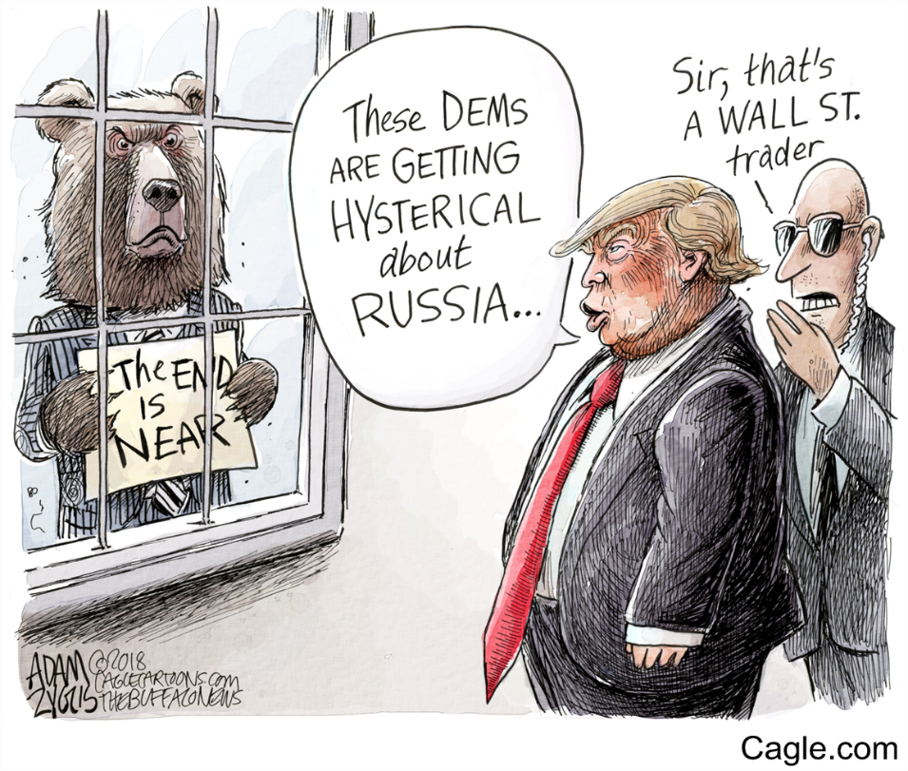 | Explanation:
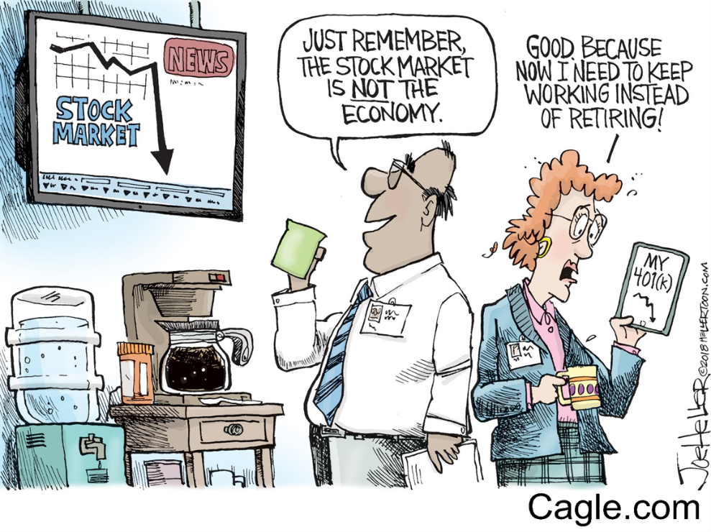 | Explanation:
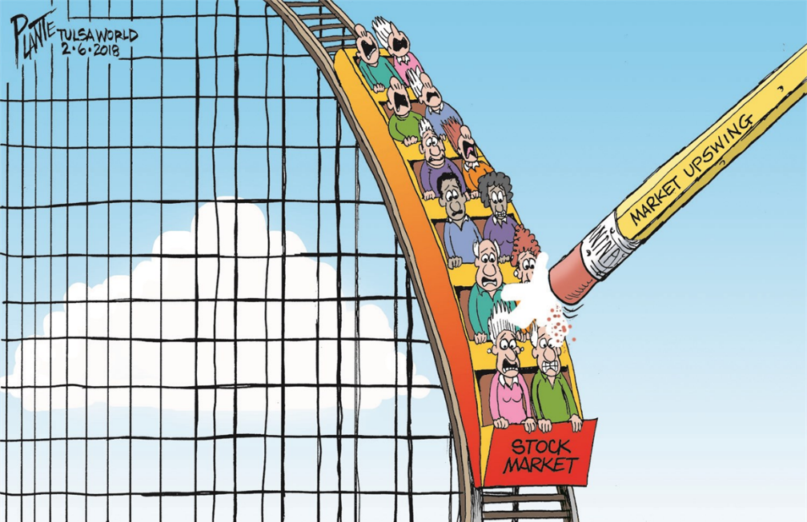 | Explanation:

