Grading the Presidents

Franklin Roosevelt is widely considered one of the greatest Presidents the United States has ever had. Since his death, how have his successors done in office? Based on the Roles of the Presidency, you will place the President assigned to you in one of the five letter grade categories (A,B,C,D,F) after considering how they did during their years in office. In your research, look for specific Presidential actions or inactions that support the grade you choose for each role of the Presidency. You will document three specific pieces of evidence for each “Role.” You will complete a grade for each role and then arrive at a final grade for the President overall based on the grades you’ve given that President in the roles.

Here are the last 13 U.S. Presidents who have completed an allotted term:

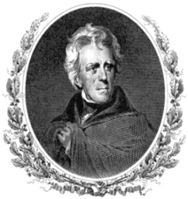Trump (2017-2021)  
Obama (2009-2017)  
Bush (2001-2009)  
Clinton (1993-2001)  
Bush (1989-1993)  
Reagan (1981-1989)  
Carter (1977-1981)  
Ford (1974-1977)  
Nixon (1969-1974)  
Johnson (1963-1969)  
Kennedy (1961-1963)  
Eisenhower (1953-1961)  
Truman (1945-1953)

The Roles of the Presidency

Commander in Chief  
Economic Planner  
Head of State  
Chief Executive  
Crisis Manager  
Chief Diplomat  
Chief Legislator  
Party Leader

EX: Andrew Jackson – *Chief Legislator Role  
 Grade – D+*

* The Panic of 1937 is directed related to Jackson’s insistence on intervening in the Legislative affairs of Congress and disrupting their work in solving the banking crisis (Chief Legislator)
* Succeeded in representing the common man in his fight against the national bank and defeating the re-charter with his veto power (Chief Legislator)
* Failed in numerous attempts to get the Electoral College abolished, which was a key legislative goal of his (Chief Legislator)