C:\Users\Jeff\AppData\Local\Microsoft\Windows\Temporary Internet Files\Content.IE5\WRV911IX\MCj03120940000[1].wmfHave Prices Really Gone Up?

GDP Per Capita has risen considerably in the last 75 years, but to what extent are consumers actually benefitting? Inflation raises nominal GDP quite substantially, but to what extent have REAL GDP Per Capita gains helped the average consumer?

Visit: <https://www.thebalance.com/real-gdp-per-capita-how-to-calculate-data-since-1946-3306028>

Take a look at the gains from year to year and some of the reasons why the economy may have changed.

Visit: <http://www.usinflationcalculator.com/>

*Using the Consumer Price Index Calculator, figure out what the following would cost in their given year.*

|  |  |
| --- | --- |
| If parents were to purchase a comparably priced item to Mario Kart 8 Deluxe ($59.99) for the Nintendo Switch for their children in 1955, how much would they be expecting to spend? | $ |
| Finding one penny in 1920 would be the same as finding what amount of money this year? | $ |
| If you were to order a 20x20 burger (twenty meat patties) at In-N-Out Burger for $24.00 today, how much would the 20x20 cost you in 1948 when the first In-N-Out restaurant opened? | $ |
| Your parents decide to give you an allowance of $0.50 per week in 1957. What would a comparable allowance today be? | $ |
| If Steph Curry had signed his $201 million dollar* contract in 1985, how much would it have been worth then? (*signed in 2017) | $ |
| You need marshmallows for your S’mores. If they cost $3.35 for a 16 oz bag today, how much will it cost you to complete your toasted delight in 1961? | $ |
| Your grandpa finds $25.00 in an old wallet that he last used in 1965. If he would have invested it in an account that earned a rate matching inflation, how much would it have been worth today? | $ |
| The slurpee that you purchased cost you $1.92 with tax included. How much would you have paid if you purchased the same slurpee in 1988? | $ |

Inflation of goods and services is not the same for all things. If a movie cost 25 cents in 1954, the value of those 25 cents is today is ~$2.00. However, we know that movies cost much more than $2.00. Therefore we can say that movies prices have increased in price **FASTER** than the average goods and service. If a cost is higher than the CPI would indicate, it is Faster. If it is lower, is it Slower.

Have the following goods and services increased in price **Faster** or **Slower** than average goods?

|  |  |  |  |
| --- | --- | --- | --- |
| **Product:** | **Former Cost** | **Current Cost** | **Faster or Slower? & What Price Would We Expect?** |
| Ford Mustang | $2,812.00 (1964) | $34,095.00 (2017) |  |
| Big Mac | $0.45 (1967) | $5.30 (2019) |  |
| 4-Bedroom Condominium  (West San Jose) | $56,000 (1975) | $1.5 million (2019) |  |
| Gasoline | $0.27/gallon (1949) | $2.77/gallon (2019) |  |
| Admission cost at Disneyland (one park ticket) | $1.00 (1955) | $129.00 (2019) |  |

Think about some of the products that have moved slower or faster than the CPI would estimate that they would have. What might be some reasons that you can think of that might explain why they were slower or faster? Use **two examples** and try to **provide evidence** that you can think of.

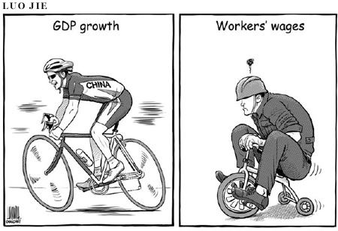

Based on what you see with the political cartoon… what is the message regarding GDP growth?