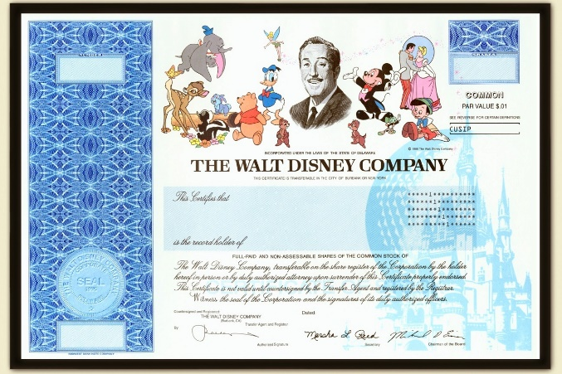The War for Disney

One of the risks of being a publicly traded company is that the company loses control. If shares of the company are held by a wide variety of diverse individuals, there is not a great risk of someone from the outside seizing control of the company. However, if someone does start to gain a significant portion of public shares, the race could be on to see who will control the company. This is the story of the Walt Disney Company and a potential takeover that occurred in the early 1980s.

If you would like a little backstory on why the Disney Company found itself in a troubling position with it’s stock in the 1980s you can watch Part 1 of Midway to Main Street’s Disney Hostile Takeover Series [What Would Walt Do?](https://www.youtube.com/watch?v=PQFHCMmEi1s)

To jump right into the assignment, catch the story at Part 2.

Watch: [Saul Steinberg, Disney's Worst Enemy - The 1984 Disney Hostile Takeover Attempt](https://www.youtube.com/watch?v=-um5Ls7OVsA)

1. *Describe Corporate Raiding:*

1. *What are the strategies of Corporate Raiding (What are they attempting to do?):*

1. *What is Green Mail and why is green mail generally bad for companies that use the strategy?:*

1. *White Knights can be risky… why?:*

1. *Roy E. Disney resigned from the board and considered buying the company himself, but he didn’t have the money. What was the potential strategy he was considering to make it happen?*

Watch: [The Disney of Boca Raton - The 1984 Disney Hostile Takeover Attempt](https://www.youtube.com/watch?v=4q-b8mP0ayM)

1. *As Arvida is seeking to become independent from the Penn Railroad, how do the Bass Brothers get involved with the possible transaction?*

1. *Richard Rainwater suggests to that Disney buy Arvida… why? And how do the Bass brothers benefit?*

Watch: [Disney's $300 Million Showdown - The 1984 Disney Hostile Takeover Attempt](https://youtu.be/tHnwSaffSQQ?si=uY3krx4QmpmKqm_H)

1. *Gibson Greetings was proposed as a merger partner with Disney. Why? What benefits might it bring?*

1. *Roy E. Disney is back, but this time with Saul Steinberg. What was he seeking in the arrangement with Steinberg?*

*10. As Steinberg gets enough backers to gain 49% of the company, Disney has two final options… Describe them:*

*-Poison Pill:*

*-Green Mail:*

If you would like to, you can finish the story below in the fifth and final episode of this series, of how Disney finally turned the corner. This is optional:

[Disney's New Prince - The 1984 Disney Hostile Takeover Attempt](https://youtu.be/OM9444N134c?si=wKP_WttGppIF3xHe)